Data Analysis Problem
Problem 1
We have photometry and radial velocities data of the Cepheid type star HV2257, in Table 1-3 based on the observation by Gieren (MNRAS vol 265, 1993) . The pulsating period of the star is $P=39.294 days$. A reference graph for temperature – color relation and bolometric correction tables are given in Figure 1 (Houdashelt et al., 2000) and Table 4 (http://xoomer.virgilio.it/hrtrace/Straizys.htm). Given also that the solar luminosity is $L_{⨀}=3.96×{10}^{26}J s^{-1}$ and its bolometric magnitude $M_{⨀bol}=4.72$.
- Plot the light curve based on Table 1, only between phase 0.6 and 1
- Plot the color in Table 2, only between phase 0.6 and 1
- Plot the Radial Velocity curve from Table 3, only between phase 0.6 and 1
- Calculate the distance to this pulsating star by using the observed data and supplementary data given in Table 4 and Figure 1. We assume that no extinction to this direction.
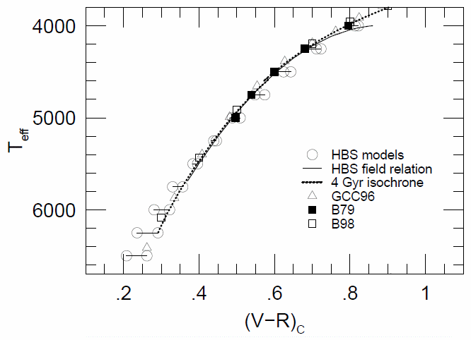
Fig. 1 The V-R color and temperature relation. Different symbol means different authors.

Table 1 Table 2 Table 3
Phase | V mag |  | Phase | V – R |  | Phase | RadVel (km/s)
0.11 | 12.81 |  | 0.22 | 0.71 |  | 0.03 | 232
0.13 | 12.84 |  | 0.24 | 0.73 |  | 0.05 | 234
0.14 | 12.87 |  | 0.25 | 0.74 |  | 0.08 | 234
0.16 | 12.88 |  | 0.27 | 0.75 |  | 0.08 | 237
0.19 | 12.90 |  | 0.29 | 0.75 |  | 0.13 | 242
0.19 | 12.94 |  | 0.29 | 0.75 |  | 0.13 | 246
0.24 | 12.99 |  | 0.34 | 0.77 |  | 0.18 | 243
0.43 | 13.32 |  | 0.51 | 0.87 |  | 0.20 | 249
0.46 | 13.31 |  | 0.53 | 0.85 |  | 0.23 | 250
0.46 | 13.32 |  | 0.53 | 0.87 |  | 0.28 | 254
0.51 | 13.36 |  | 0.57 | 0.85 |  | 0.33 | 259
0.54 | 13.41 |  | 0.60 | 0.87 |  | 0.35 | 261
0.54 | 13.45 |  | 0.60 | 0.88 |  | 0.36 | 260
0.56 | 13.46 |  | 0.62 | 0.87 |  | 0.38 | 266
0.59 | 13.53 |  | 0.64 | 0.90 |  | 0.40 | 265
0.59 | 13.52 |  | 0.64 | 0.90 |  | 0.44 | 266
0.61 | 13.55 |  | 0.66 | 0.88 |  | 0.46 | 272
0.64 | 13.60 |  | 0.68 | 0.91 |  | 0.46 | 265
0.64 | 13.62 |  | 0.69 | 0.90 |  | 0.49 | 270
0.72 | 13.68 |  | 0.76 | 0.88 |  | 0.51 | 270
0.74 | 13.61 |  | 0.78 | 0.82 |  | 0.54 | 272
0.77 | 13.45 |  | 0.80 | 0.79 |  | 0.54 | 273
0.79 | 13.18 |  | 0.82 | 0.70 |  | 0.56 | 274
0.80 | 13.12 |  | 0.82 | 0.70 |  | 0.59 | 274
0.80 | 13.07 |  | 0.82 | 0.68 |  | 0.61 | 273
0.82 | 12.80 |  | 0.84 | 0.60 |  | 0.62 | 274
0.82 | 12.78 |  | 0.84 | 0.59 |  | 0.64 | 274
0.82 | 12.73 |  | 0.84 | 0.58 |  | 0.67 | 276
0.84 | 12.57 |  | 0.86 | 0.53 |  | 0.67 | 274
0.85 | 12.54 |  | 0.86 | 0.51 |  | 0.69 | 274
0.85 | 12.53 |  | 0.87 | 0.52 |  | 0.71 | 274
0.87 | 12.48 |  | 0.88 | 0.51 |  | 0.72 | 276
0.87 | 12.47 |  | 0.89 | 0.51 |  | 0.74 | 278
0.89 | 12.49 |  | 0.90 | 0.55 |  | 0.77 | 271
0.90 | 12.51 |  | 0.91 | 0.53 |  | 0.77 | 264
0.92 | 12.51 |  | 0.93 | 0.56 |  | 0.79 | 253
 |  |  |  |  |  | 0.80 | 259
 |  |  |  |  |  | 0.82 | 242
 |  |  |  |  |  | 0.85 | 230
 |  |  |  |  |  | 0.87 | 228
 |  |  |  |  |  | 0.90 | 224
 |  |  |  |  |  | 0.92 | 224
 |  |  |  |  |  | 0.92 | 225
 |  |  |  |  |  | 0.95 | 228
 |  |  |  |  |  | 0.96 | 228
Table 4. Bolometric correction
T_{eff}, K | BC, mag
9600 | -0.25
9400 | -0.16
9150 | -0.10
8900 | -0.03
8400 | 0.05
8000 | 0.09
7300 | 0.13
7100 | 0.11
6500 | 0.08
6150 | 0.03
5950 | 0.00
5800 | -0.05
5500 | -0.13
5250 | -0.22
5050 | -0.29
4950 | -0.35
4850 | -0.42
4700 | -0.57
4600 | -0.75
4400 | -1.17
3900 | -1.25
3750 | -1.40
3550 | -1.60
3400 | -2.00

Problem 2

You are given BVRIJHKLMN photometry of 2 stars from the constellation Cassiopeia (Table 5). For both, it is believed that their light is affected by extinction on diffuse ISM only.
- Using the data given in Tables 5 to 9, plot $E_{X-V}/E_{B-V}$ as a function of $1/λ_{X}$ for filters B, V, R, I, J, H, K, L, M, N for both stars, fitting appropriate curves to guide the eye (in particular, note that $E_{X-V}/E_{B-V}\sim const.$ as $1/λ_{X}→0$).
- Using the graphs obtained in a), estimate $R_{V}$ and $R_{r}$ for each star and hence find the expected values of these parameters corresponding to diffuse ISM in our Galaxy.

You are now going to apply these results in order to derive a distance estimate for IC 342, a spiral galaxy in Cassiopeia obscured by Milky Way. You should assume that the properties of ISM in IC 342 are similar to those of ISM in our Galaxy.
- Using the period-magnitude diagrams for 20 Cepheids from IC 342 (Figures 2 and 3) and assuming the period-luminosity relations

$〈M_{r}〉=-2.91\left(\log\left(\frac{P}{day}\right)-1\right)-4.04$ and $〈M_{i}〉=-3.00\left(\log\left(\frac{P}{day}\right)-1\right)-4$.06

where $〈M_{r,i}〉$ are the mean absolute magnitudes in filters r and i, find $A_{r}$ for objects in IC 342,
and using the conversion formula
$$R_{r,r-i}=\frac{A_{r}}{E_{r-i}}=\left(\frac{E_{r-V}}{E_{B-V}}+\frac{A_{V}}{E_{B-V}}\right)\frac{E_{B-V}}{E_{r-i}}=\frac{\frac{E_{r-V}}{E_{B-V}}+R_{V}}{\frac{E_{r-V}}{E_{B-V}}-\frac{E_{i-V}}{E_{B-V}}},$$

find the distance to IC 342.
Table 5 BVRIJHKLMN photometry of two stars in Cassiopeia
Star | MK class | $$\frac{B}{mag}$$ | $$\frac{V}{mag}$$ | $$\frac{R}{mag}$$ | $$\frac{I}{mag}$$ | $$\frac{J}{mag}$$ | $$\frac{H}{mag}$$ | $$\frac{K}{mag}$$ | $$\frac{L}{mag}$$ | $$\frac{M}{mag}$$ | $$\frac{N}{mag}$$
HD 4817 | K3Iab | 8.08 | 6.18 | 4.73 | 3.64 | 2.76 | 1.86 | 1.54 | 1.32 | 1.59 | -
HD 11092 | K4II | 8.66 | 6.57 | - | - | 3.10 | 2.14 | 1.63 | 1.41 | 1.65 | 1.44

Table 6 ${\left(B-V\right)}_{0}$ intrinsic colours for selected sp. types and luminosity classes
 | $$\frac{{\left(B-V\right)}_{0}}{mag}$$
 | II | Iab / Ia
F0 | - | 0.15
G0 | 0.73 | 0.82
K0 | 1.06 | 1.18
K3 | 1.40 | 1.42
K4 | 1.42 | 1.50

Table 7 Infrared intrinsic colours for selected sp. types of supergiant stars
 | $$\frac{{\left(V-R\right)}_{0}}{mag}$$ | $$\frac{{\left(V-I\right)}_{0}}{mag}$$ | $$\frac{{\left(V-J\right)}_{0}}{mag}$$ | $$\frac{{\left(V-H\right)}_{0}}{mag}$$ | $$\frac{{\left(V-K\right)}_{0}}{mag}$$ | $$\frac{{\left(V-L\right)}_{0}}{mag}$$ | $$\frac{{\left(V-M\right)}_{0}}{mag}$$ | $$\frac{{\left(V-N\right)}_{0}}{mag}$$
F0 | 0.20 | 0.31 | 0.36 | 0.51 | 0.60 | 0.64 | 0.65 | 0.82
G0 | 0.55 | 0.90 | 1.14 | 1.52 | 1.71 | 1.72 | 1.72 | 1.98
K0 | 0.95 | 1.59 | 2.01 | 2.64 | 2.80 | 2.87 | 2.79 | 3.14
K3 | 1.13 | 1.96 | 2.41 | 3.14 | 3.25 | 3.39 | 3.25 | 3.63
K4 | 1.20 | 2.13 | 2.59 | 3.37 | 3.44 | 3.62 | 3.46 | 3.84

 | $$\frac{{\left(V-R\right)}_{0}}{mag}$$ | $$\frac{{\left(V-I\right)}_{0}}{mag}$$ | $$\frac{{\left(V-J\right)}_{0}}{mag}$$ | $$\frac{{\left(V-H\right)}_{0}}{mag}$$ | $$\frac{{\left(V-K\right)}_{0}}{mag}$$ | $$\frac{{\left(V-L\right)}_{0}}{mag}$$ | $$\frac{{\left(V-M\right)}_{0}}{mag}$$ | $$\frac{{\left(V-N\right)}_{0}}{mag}$$
K0 | 0.60 | 1.03 | 1.23 | 1.72 | 1.94 | 1.97 | 1.90 | 1.92
K3 | 0.86 | 1.39 | 1.84 | 2.40 | 2.69 | 2.82 | 2.70 | 2.73
K4 | 0.96 | 1.61 | 2.16 | 2.77 | 3.05 | 3.22 | 3.08 | 3.02
Table 8 Infrared intrinsic colours for selected sp. types of giant stars
Table 9 Effective wavelengths of selected photometric filter
Filter | B | V | R | I | J | H | K | L | M | N | r | i
$$λ_{F}/nm$$ | 450 | 555 | 670 | 870 | 1200 | 1620 | 2200 | 3500 | 5000 | 9000 | 650 | 820
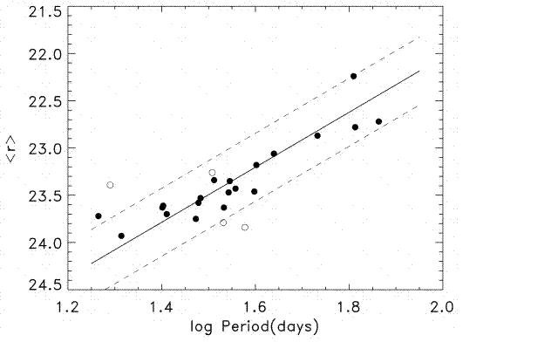
Fig. 2 $〈r〉$ is the mean apparent magnitude in filter r
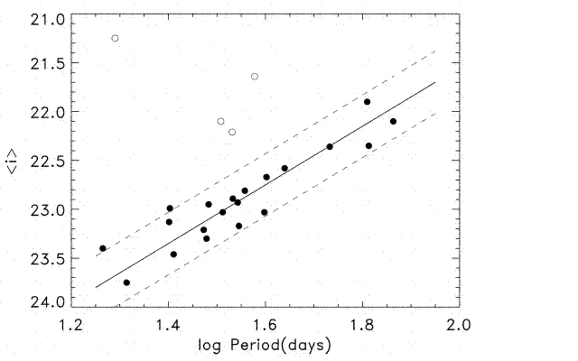
Fig. 3 $〈i〉$ is the mean apparent magnitude in filter i

